Unit 4: Food
Lesson 14: What's for breakfast?

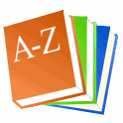DICTIONARY-RJEČNIK
1 Listen and point. Repeat.
Poslušaj učiteljicu i pokaži sliku. Ponovi riječ.

https://drive.google.com/file/d/1NiEGBxg9Dh2mi55hVWLGA0J7EGEdGzrd/view

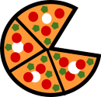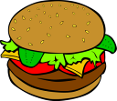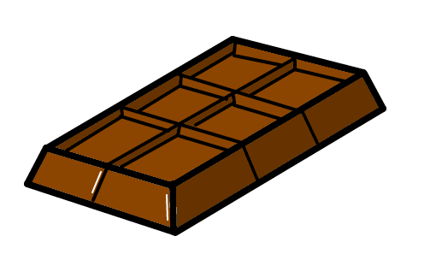
PIZZA HAMBURGER CHOCOLATE

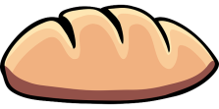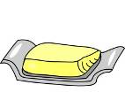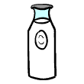
BREAD BUTTER MILK

2 Listen. Tick the picture.
Poslušaj učiteljicu. Sliku označi kvačicom.

https://drive.google.com/file/d/1Wx00BLOjbfBX_gysF1W0Yo72Uccx3aJU/view



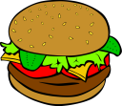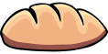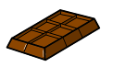

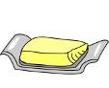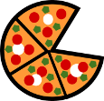

3 Match the pictures to the words.
Spoji slike s riječima.

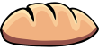 HAMBURGER
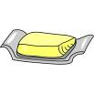 PIZZA
BREAD
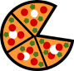 CHOCOLATE
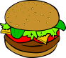 BUTTER
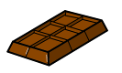 MILK

