DIP IN 8

LESSON 15 - Healthy and happy
1 Read the conversation. Pročitaj razgovor.

VEGAN = vegan osoba koja ne jede meso ni proizvode koje dolaze od životinja.
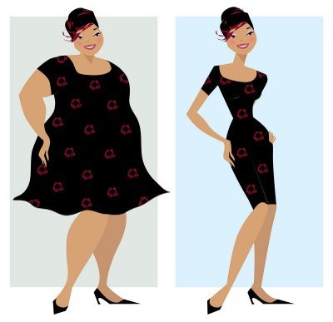

KEIRAN: Look at me, Nikki. I'm overweight.

NIKKI: No, you look great!
You are not overweight.

KEIRAN: Oh, I must go on a diet.

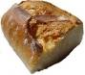
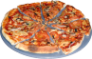
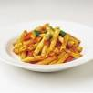
NIKKI:

Will you stop eating bread , pasta and pizza?
KEIRAN: No, I love bread, pasta and pizza.
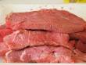
I will stop eating meat
. I will be a vegan.
NIKKI: A vegan? No food coming from animals.
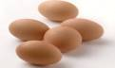
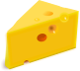
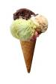
No eggs, cheese and ice cream.

KEIRAN:
No ice cream?! But I love chocolate ice cream!
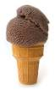
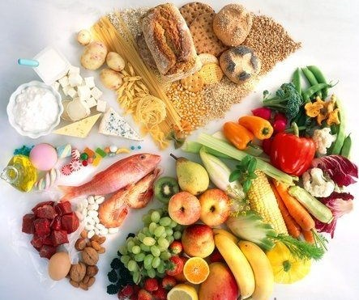
NIKKI:
Then eat normally.


Do sports and let's go for a pizza.

KEIRAN: Great idea!

Keiran: Pogledaj me, Nikki. Debela sam!
Nikki: Nisi, izgledaš izvrsno. Nisi debela.
Keiran: Oh, moram na dijetu.
Nikki: Hoćeš li prestati jesti kruh, tjesteninu i pizzu?
Keiran: Ne, ja volim kruh, tjesteninu i pizzu.
Prestat ću jesti meso. Bit ću vegan.
Nikki: Vegan? Bez hrane životinjskog podrijetla? Bez jaja sira i sladoleda?
Keiran: Bez sladoleda?! Ali ja volim sladoled od čokolade.
Nikki: Onda jedi normalno. Bavi se sportom i idemo na pizzu.
2 Circle the correct translation. Zaokruži točan prijevod.

OVERWEIGHT mršava debela
LOOK GREAT izgledati izvrsno izgledati loše
GO ON A DIET ići u školu ići na dijetu
A VEGAN vegan mačka
FOOD kuća hrana
ANIMALS životinje automobili
EAT NORMALLY jesti normalno jesti mnogo
DO SPORTS baviti se sportom učiti

3 Translate into Croatian. Prevedi na hrvatski jezik.

GO ON A DIET __________________________
FOOD _________________________
DO SPORTS __________________________
ANIMALS __________________________
OVERWEIGHT __________________________
EAT NORMALLY _________________________
LOOK GREAT __________________________
A VEGAN __________________________

4 Read the conversation between Keiran and Nikki again. Read the sentences and circle TRUE or FALSE.
Pročitaj ponovno razgovor između Keiran i Nikki. Pročitaj rečenice i zaokruži TOČNO ili NETOČNO.

- Keiran is overweight. TRUE FALSE
- Keiran looks great. TRUE FALSE
- Keiran wants to go on a diet. TRUE FALSE
- Keiran will stop eating pizza. TRUE FALSE
- Keiran will stop eating meat. TRUE FALSE
- Keiran loves chocolate ice cream. TRUE FALSE
- Nikki thinks it's better to eat normally TRUE FALSE
and do sports.

5 Read and think. Look at the pictures. Pročitaj i razmisli. Pogledaj sličice.

- Does Nikki think Keiran should go on a diet? Why?
(Smatra li Nikki da bi Keiran trebala ići na dijetu? Zašto?)

- Why does Nikki think Keiran should eat normally?
(Zašto Nikki misli da Keiran treba jesti normalno?)

- Why does Nikki think Keiran should do sports?
(Zašto Nikki misli da bi se Keiran trebala baviti sportom?)
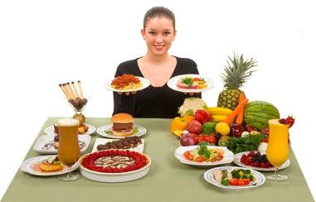

6 Finish the mind maps with your own ideas.
Use the pictionary to help you.
Dovrši umne karte vlastitim primjerima.
Koristi se slikovnim rječnikom kao pomoć.

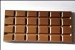
chocolate

WHAT IS SWEET?
(Što je slatko?)

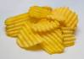
WHAT IS SALTY?
(Što je slano?)

crisps

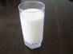
milk

WHAT IS HEALTHY?
(Što je zdravo?)

WHAT IS UNHEALTHY?
(Što je nezdravo?)

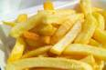

chips

7 Look at the picture. Circle the correct sentence.
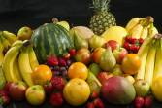
Pogledaj sličicu. Zaokruži točnu rečenicu.

Fruit is healthy.
Fruit is unhealthy.

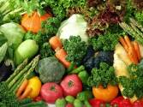
Vegetables are healthy.
Vegetables are unhealthy.
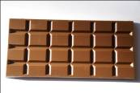
Chocolate is salty.
Chocolate is sweet.

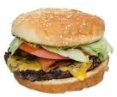
Hamburgers are sweet.
Hamburgers are salty.

8 Answer the questions about yourself.
Use: YES, I DO. NO, I DON'T.
Odgovori na pitanja o sebi. Upotrijebi: YES, I DO. NO, I DON'T.

- Do you do sports? _______________________
- Do you eat healthily? _______________________
- Do you like sweet food? _______________________
- Do you like salty food? _______________________
- Do you have breakfast every day? _______________
- Do you have a friend who is a vegan? _____________

PICTIONARY
- FRUIT
apple | 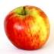
banana | 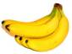
grapes | 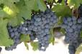
kiwi | 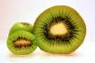
lemon | 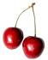
orange | 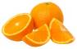
peach | 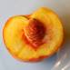
pear | 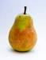
pineapple | 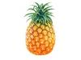
plum | 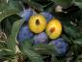
strawberry | 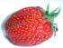
watermelon | 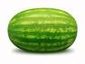

- VEGETABLES
beans | 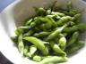
broccoli | 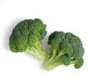
cabbage | 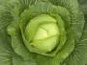
carrot | 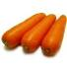
cauliflower | 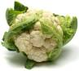
corn | 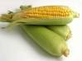
lettuce | 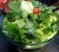
mushroom | 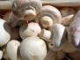
olives | 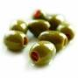
onion | 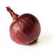
potato | 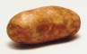
tomato | 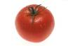

- MEAT AND FISH
beef | govedina
chicken | piletina
duck | patka
ham | šunka
lamb | janjetina
pork | svinjetina
sausages | kobasice
trout | pastrva
tuna | tunjevina
turkey | puretina

- DRINKS
cocoa | 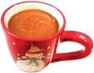
coffee | 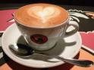
juice | 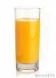
milk | 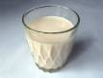
tea | 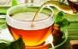
water | 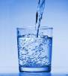

- OTHER
biscuits | 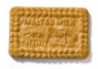
bread | 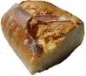
butter | 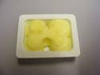
cake | 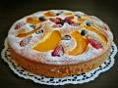
candies | 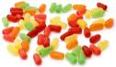
cereal | 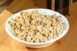
cheese | 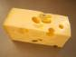
chips | 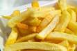
egg | 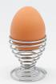
flour | 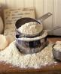
hot dog | 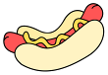
jam | 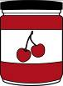
oil | 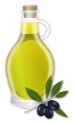
pancakes | 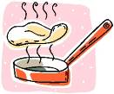
pasta | 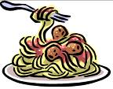
rice | 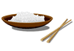
salt | 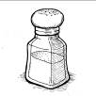
sugar | 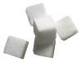
yoghurt | 

